28.80: Two infinite sheets, as in Problem 28.79, are placed one above the other, with their currents opposite.
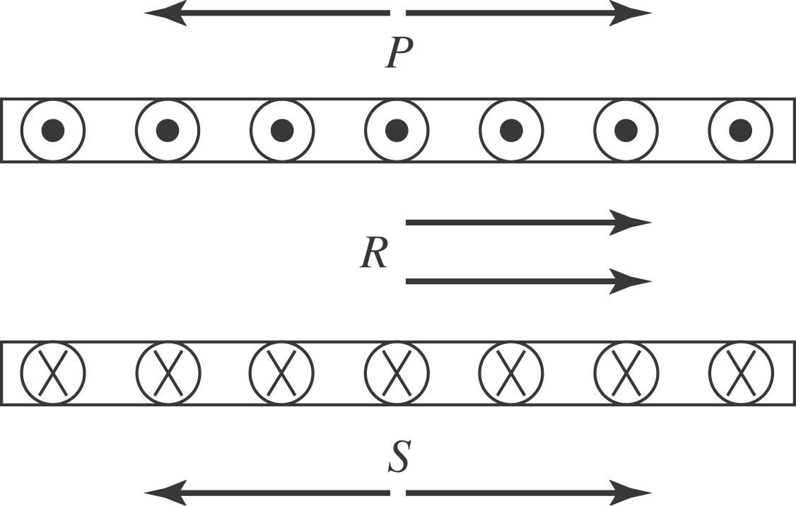

a) Above the two sheets, the fields cancel (since there is no dependence upon the distance from the sheets).
b) In between the sheets the two fields add up to yield 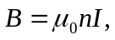to the right.
c) Below the two sheets, their fields again cancel (since there is no dependence upon the distance from the sheets).

